# **Biodiversity**

1. Introduction
   1. Understanding the dataset
   2. What we solved
2. Research and visualization
   1. Conservation status
   2. Protection status of species
   3. Endangered species
   4. Threatened species
   5. Concern species
   6. Most detailed
   7. Parks that Vermivora Bachmanii is endangered
   8. Most species are concerned
   9. Conservation status in Yosemite National Park
3. Conclusions

## **Introduction**

In recent centuries, human activities have inflicted harm on animals, resulting in the extinction of numerous species.

Consequently, we bear a profound responsibility to conserve and protect the species that remain.

This report delves into the analysis of the National Parks Service, focusing on endangered species across various parks and their current conservation status.

### **1.1 Understanding the dataset**

Our analysis hinges on two crucial CSV files, "observation" and "species." These datasets contain the following key columns:

* **scientific_name** : Scientific names of the observed species
* **park_name**: Name of parks where observation occured
* **observations**: How many time that species observed
* **category**: Categorization of species
* **conservation_status** : The conservation status of each species

### **1.2 Hands on data**

To ensure the robustness of our analysis, we undertook a rigorous data cleaning process, addressing duplicate entries and handling null values. Additionally, we integrated the two datasets, setting the stage for answering critical questions:

1. How many species we protected, and what are their conversion statuses?
2. what is most protected species Whitin its category and overall?
3. Which species are most endangered?
4. Which species face the highest threat levels?
5. What species fall under the category of concern?
6. Which conservation status is most prevalent among species and parks?

## **Analysis**

### **conversion status**

Out of 5633 species, a noteworthy observation is that a substantial number remain unprotected. Further details on other conservation statuses will be explored in the subsequent sections.

**Conservation status size**

Endangered 16

In Recovery 4

No Intervention 5633

Species of Concern 161

Threatened 10

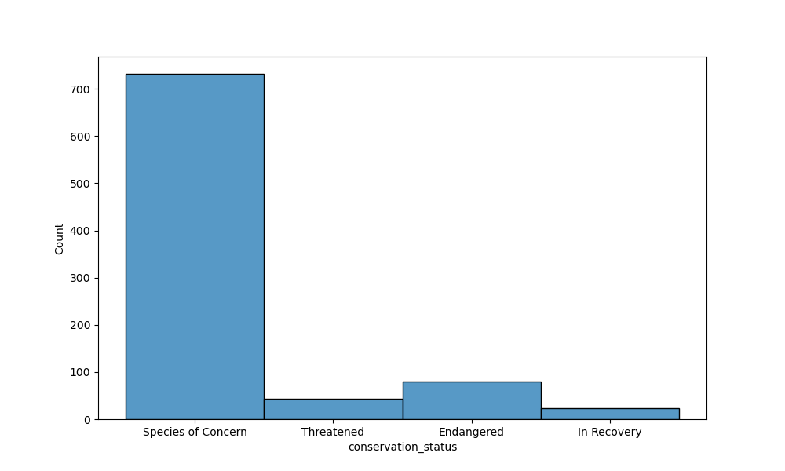

### **protection status of species**

A mere 1% of Vascular plants and 2% of Nonvascular plants are currently protected, representing a strikingly low percentage compared to other species. Particularly noteworthy is the fact that Mammals and Birds are the most protected species within their respective categories, accounting for approximately 42% of all protected species.

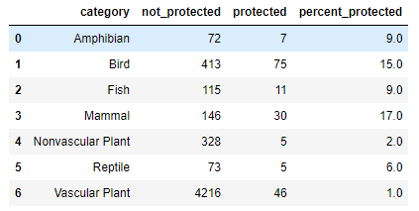

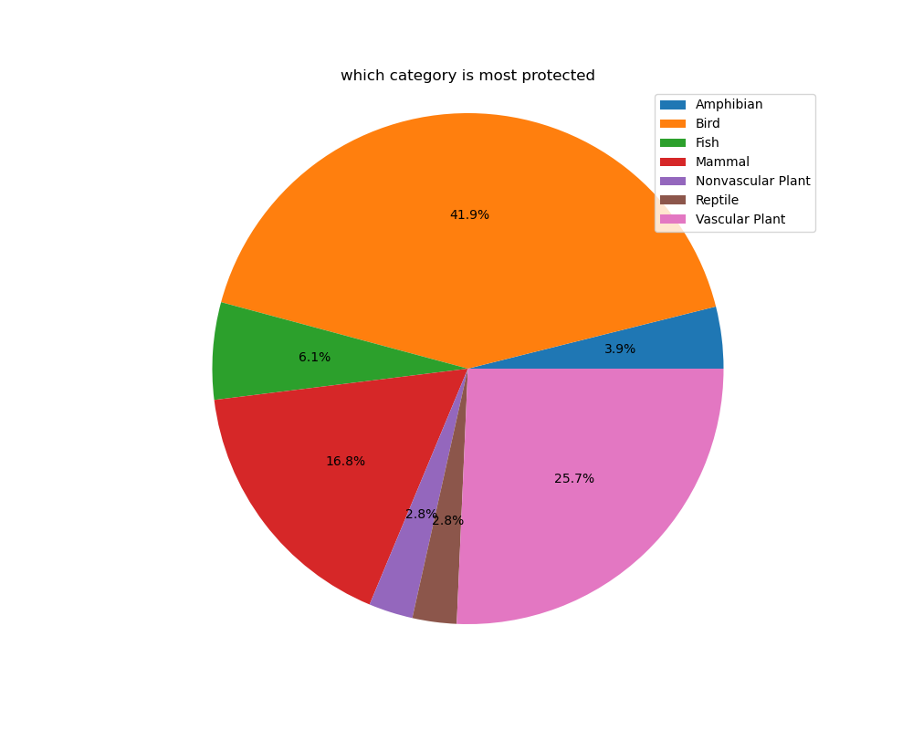

### **Endangered species**

An alarming 55% of endangered species fall into the Mammals category, while Vascular plants and Amphibians together constitute only 10%. This disparity becomes evident when breaking down the percentages, with Mammals ranking highest at 55%, followed by Vascular plants and Amphibians at 5% each.

### **Threatened species**

Human activities significantly threaten various species, particularly aquatic life. Fishes, facing twofold higher threats compared to other species, bear the brunt of water pollution.

### **2.5 Species of Concern**

Birds, Mammals, and Vascular plants are the species of greatest concern, commanding attention due to their respective statuses respective.

### **2.6 Brief details**

***Endangered Species:***

* Most Endangered Species: Vermivora bachmanii
* Park with the Most Endangered Species: Yosemite National Park
* Most Endangered Animal Category: Vascular Plant

***In Recovery:***

* Most Species In Recovery: Pelecanus occidentalis
* Park with the Most In Recovery Species: Yosemite National Park
* Most In Recovery Animal Category: Mammal

***Species of Concern:***

* Most Species of Concern: Zizia trifoliata
* Park with the Most Species of Concern: Yosemite National Park
* Most Species of Concern Animal Category: Vascular Plant

***Threatened Species:***

* Most Threatened Species: Ursus arctos horribilis
* Park with the Most Threatened Species: Yosemite National Park
* Most Threatened Animal Category: Vascular Plant

### **2.7** **Parks that Vermivora Bachmanii is endangered**

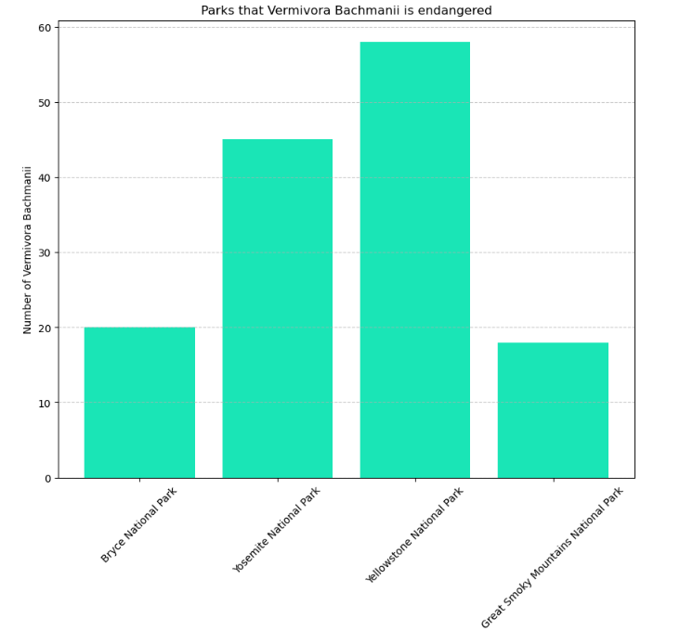

Yellowstone National Park is the habitat where the endangered species Vermivora Bachmanii faces the most significant threat.

### **2.8 Most species are concerned**

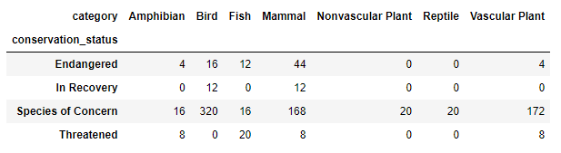

Across all conservation statuses, the majority of species fall under the category of concern.

### **2.9** **Conservation status in Yosemite National Park**

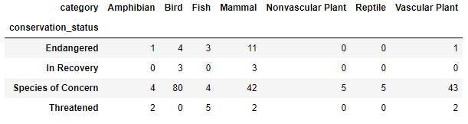

Yosemite National Park exhibits the highest frequency across all conservation statuses, signifying a need for further investigation into the well-being of its diverse species.

## **Conclusions**

* Birds are the most widely protected and concerned species, but the analysis reveals a substantial number of overlooked species.
* Mammals face the highest endangerment levels, warranting attention similar to that given to birds.
* Fishes, while the most threatened, receive the least concern, indicating a need for focused research and conservation efforts.